**Lecture # 4 EFFICIENT FRONTIER**

* Investors should select portfolios on the basis of expected return and risk
* A portfolio is efficient if:

1. it has the smallest level of risk for a given return or

2. largest return for a given level of risk

* To select efficient portfolios, investors should find out all portfolios opportunities set i.e. find out risk and return set for all portfolios
* Example given in the Excel File

**Steps:**

1. Calculate securities return

2. calculate portfolio returns

3. Find portfolio risk

4. Make different portfolios by changing weights of the securities

5. Find risk and return of each portfolio developed in step 4

6. Plot the risk and return of these portfolios

7. Find the minimum variance portfolio

8. Portfolios above the minimum variance portfolios are efficient

* It is a line that shows risk and return combination of all efficient portfolios
* Any portfolio that is below this frontier is considered less efficient because:
  + It has either higher risk for the same level of return or
  + Lower return for the same level of risk

All rational investors will invest only in portfolios that lie on efficient frontier

Aggressive investors will invest in portfolios on the upper left of the efficient frontier

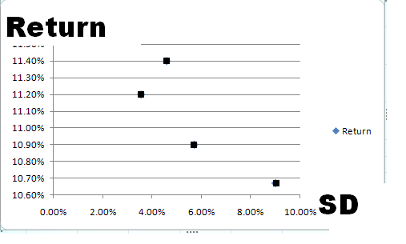

**Capital Market Theory**

* After Markotwitz, William Sharp presented capital market theory
* He analyzed the effect of risk free asset on a portfolio

He proved that when a risk free asset is combined with a risky portfolio, the risk of the new portfolio considerably declines without significant decline in the return of the new portfolio

**Risk free asset**

* The return on a risk free asset is fixed hence the standard deviation of risk free asset is zero
* The return on risk free asset does not change with change in return of other securities, so the covariance of risk free asset with any other asset will be zero



* Suppose risk free asset is A so SD of A =0
* The first term of the equation will be removed
* The COV term will also be 0, so the last term will also be removed
* Risk of the portfolio will be



* The weight of WB is equal to WB = (1-WA)
* So we can write the above formula as
* SD of Portfolio =[(1-WA)22B]1/2 OR

SD of Portfolio =(1-WA)B

**Example**

* Suppose we made a portfolio of POL, MCB, and Engro. After trying different weights, we found out that one efficient portfolio has SD of 8%; can we reduce this SD further with no substantial reduction in return?
* YES by investing some portion of our funds in the above risky portfolio and remainder in risk-free asset.
* Suppose we invest 30% in risk free and 70% in the risky asset, the SD of our new portfolio will be?
* SD of portfolio = (1-WA)B = (1-.3)x8 = 0.7x8 = 5.6
* IF we invest 50% in risk free and 50% in risky
* SD of portfolio = (1-WA)B = (1-.5)x8 = 0.5x8 = 4
* If we invest 80% in risk free,
* SD of portfolio = (1-WA)B = (1-.8)x8 = 0.2x8 = 1.6

**Interpretation**

The formula shows that the risk of the risky portfolio falls proportionately with weight of the risk free security

* In other words, if we add 50% risk free asset to our portfolio, the overall risk of the risky portfolio will decrease by 50%

The return of the portfolio will also decrease but not by 50%: Why?



**Capital Market Line**

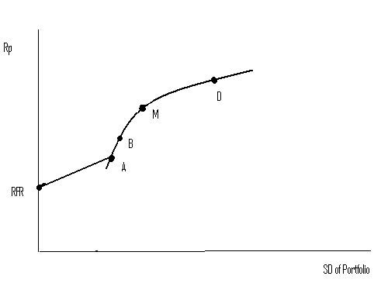

IF you invest 100% of your funds in Portfolio A, you will get R2 return with 3.1 level of risk. If you invest 100% funds in Risk free asset, you will get RFR return and 0 risk. If you invest some portion in A and other in risk free, your risk return combination is given by the line from RFR to A.

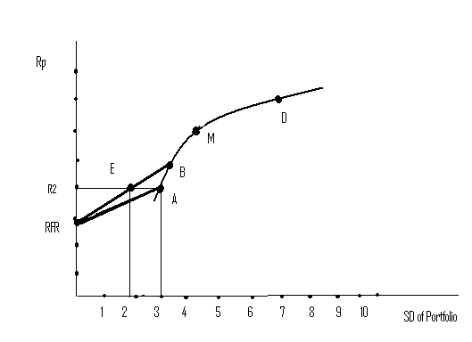

You are a risk averse investor and you want to earn a return R2 offered by Portfolio A. You can earn The same R2 with low level of risk by investing half of your investment in Portfolio B and half in Risk free asset.

**Can risk further be reduced?**

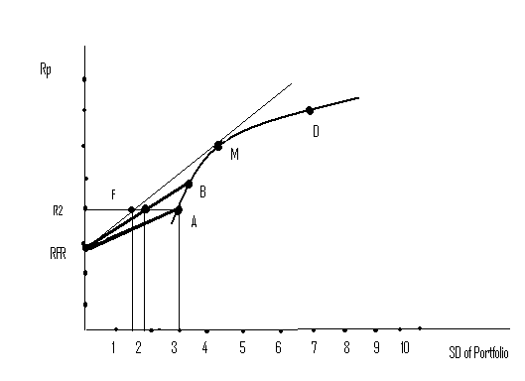

Instead of combining risk free asset with Portfolio B, if we combine it with M, the risk can further be reduced from 2 to 1.5 without reducing the return.

**Capital Market Line and Portfolio M:**

* The straight line from RFR to portfolio M is called Capital Market Line (CML)
* Any portfolio on this line dominates all other portfolio in terms of risk and return combinations
* **Question**: Why all investor will invest only in portfolio M?

**Ans:** Because no other portfolio gives the best risk-return combination as compared to Portfolio M when we combine it with risk-free asset. Rational investor who try to maximize their utilities will invest only in Portfolio M and risk-free asset

1. Why all risky assets will be included in this portfolio?

**Ans:** As all investor will invest only in Portfolio M, they will only buy those securities that are included in portfolio M. If any asset is not included in portfolio M, no one will buy it. Demand for that asset will drop down and its share price will fall to the extent that it will look too cheap, (and return on the asset will rise). Having an attractive price, ultimately the asset will gain interest among investors and included in portfolio M

1. Why it is a completely diversified portfolio?

**Ans:** The benefit of diversification increases as we increase the number of securities in our portfolio. In a large portfolio of assets, the chances of negative correlation between different assets increases. As the negative correlation increases, portfolio risk decreases. By including all risky assets in a portfolio, the portfolio becomes fully diversified.

**Capital Assets Pricing Model (CAPM):**

* Capital Asset pricing model was developed by Markowitz and William Sharpe in 1960. For which W. Sharp was awarded the noble prize in 1990. The basic purpose of this model is to find the true value of securities, based on their risk and return. The model calculate the required rate of return on a security, based on its systematic risk.

**Required Rate of Return:**

* RRR = A rate that an investor requires from his investment
* Required rate of return has two components
* RRR = **Risk free rate**+ **Risk premium on the given security**
* Risk premium depends on how risky is a security for riskier securities the risk premium is high

**Q: How to find risk premium on a security?**

**Q. Risk premium for total risk or only some portion of the total risk?**

**Risk Premium**

* William Sharp argues that investors should require risk premium only for non-diversifiable risk (systematic risk). i. e even after adding a security to a **large portfolio**, some portion of risk cannot be eliminated. The un-eliminated risk increases the risk of whole portfolio. Investors should demand risk premium only for this portion of the total risk of a security.
* **Which portfolio is a large portfolio?**
* Market portfolio is the large portfolio because:
  + All investors hold market portfolio
  + It has all types of assets
  + It is a completely diversified portfolio
* If a security has as much non-diversifiable risk as the market portfolio, risk premium on the security should equal to risk premium on the market portfolio.

**Required rate of return on a single security:**

* RRR = Rf + Risk premium on market portfolio = RRR = Rf + (Rm-Rf)
* If our security is two times more volatile than the market portfolio, then our risk premium should also double = RRR = Rf + 2x(Rm-Rf)
* If our security is half as volatile as the market portfolio, then the risk premium on our security should also be half = RRR = Rf + 0.5(Rm-Rf)
* In short, risk premium on a given security depends on how sensitive the security is in relation to market portfolio
* The sensitivity is captured with beta RRR = Rf + $β$ (Rm-Rf)

**How to Operationalize CAPM:**

* We need three variable for implementing CAPM model:
* Security returns = (Dividend +capital gain)/Po
* Return on Market portfolio = (Index1-Indexo)/Indexo
* Risk free rate = T-bill rates

*Step 1 : Calculate Ri -Rf*



**Rf = 10% >>>>> Monthly Rf = 0.10/12 = .008**

**Ri = (P1-Po)/Po**

*Step 2: Calculate Risk Premium*



***Final Variables***



* Colgate annual return = P1-Po/Po
* = (579-369)/369 = 50%
* Annual KSE Return = (1476-11272)/11272 = 24.58
* RRR on Colgate= Rf + $β$ (Rm-Rf)

= 9.22% + .48(24.5 - 9.22)

= 9.22% + .48(15.28)

= 9.22% + 7.33%

= 16.55%